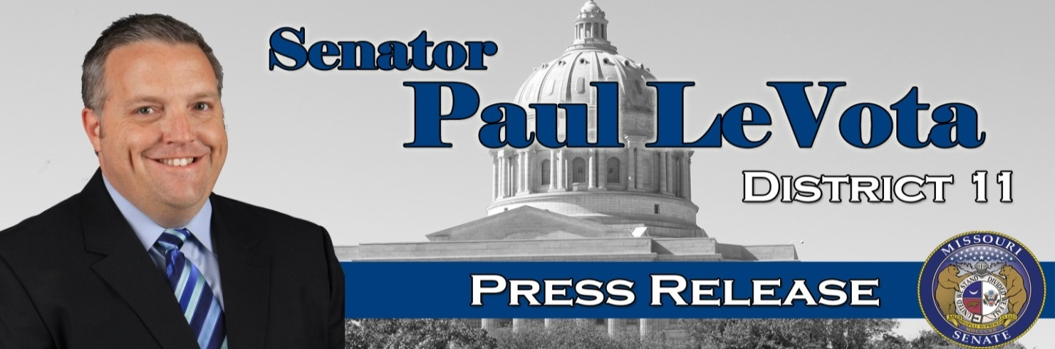
Senator Paul LeVota  11th Senatorial District  For Immediate Release:  July 24, 2015 | Capitol Building, Rm. 421  Jefferson City, Mo., 65101  Contact: (573) 751-3074
State Senator Resigns
JEFFERSON CITY — State Senator Paul LeVota, D-Independence, has released the following statement:
My conduct has been called into question relating to the intern program in the Missouri Senate and even though there has been no proof of any wrongdoing, the media attention is a distraction to doing the people’s work. As I stated before, I did not engage in any inappropriate activities with any intern in the Missouri Senate and a thorough investigation found no proof of misconduct. However, I will not put my family, myself, and the senate through the process of dealing with the veracity of false allegations and character assassination against me.

In my entire time as a public official, I have focused on issues to help people like expanding health insurance, raising the minimum wage, and equal pay for all. If anything distracts from my ability to do that work for Missouri, I cannot be as effective as my constituents deserve. With the continuing focus of these other issues, I find it difficult to be the best senator that the people elected me to be.

Today, I have tendered my resignation from the Missouri Senate to Senator Tom Dempsey effective August 23, 2015. It is important to finalize all issues in my office and to allow the governor the ability to immediately call for a special election to fill my seat. It is doubly important as House District 29 is still vacant and needs to be filled. It is imperative that the people of the 11th Senatorial District and the 29th House District have representation in Jefferson City immediately.

I want to thank all of my supporters over my years in public service and I look forward to joining the ranks as a private individual and contribute to my community in that way.

Sincerely,
Paul LeVota

#END#

